🧠 Project Title
Enterprise Multi-Site Network Design & Implementation (GUFG Case Study)

🏢 Scenario (Simplified & Clear)
You are network engineers working for Gulf Unified Financial Group (GUFG).
Your task:
- Integrate 4 different sites into one enterprise network
- Ensure:
  - Connectivity
  - Security
  - Redundancy
  - Scalability

👥 Group Work
- 4 students per group
- Each student = one site (Bahrain, KSA, Oman, Kuwait/Qatar)

⚙️ 🔥 CORE DESIGN RULES

1. Network Architecture
Students MUST follow:
- Core layer (Multilayer switches)
- Distribution layer
- Access layer
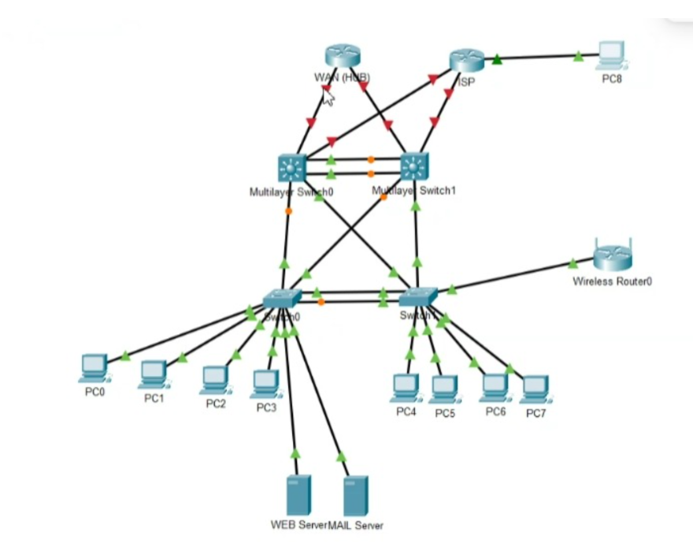
as a reference only, not a solution.

2. Routing
✔ Inside each site:
- Use dynamic routing (OSPF / EIGRP / RIP)
✔ Between sites:
- Use STATIC ROUTING via HUB

Important Notes
Traffic must go:
Spoke → Hub → Spoke
NOT directly between sites

3. IP Addressing (Given requirement)
Site | Network | Protocol
Bahrain | 10.0.0.0/16 | OSPF
KSA | 172.16.0.0/12 | EIGRP 10
Oman | 192.168.0.0/16 | EIGRP 20
Kuwait/Qatar | 172.20.0.0/16 | RIP v2

🧩 TASKS

🔹 Task 1: IP + Routing
- Design subnet per department
- Implement routing per site
- Configure static routes between sites

🔹 Task 2: VLAN Design
- Create VLAN per department
- Use:
  - Trunking
  - Inter-VLAN routing (Layer 3 switch)

🔹 Task 3: Security + Redundancy
Students MUST implement:

Security:
- Port Security
- DHCP Snooping
- SSH only
- Disable unused ports

Redundancy:
- STP (or RPVST)
- HSRP
- Redundant links

🔹 Task 4: Wireless
- Add wireless router
- Use:
  - WPA2/WPA3
  - Separate VLAN

🔹 Task 5: WAN
- PPP with:
  - PAP (one link)
  - CHAP (another link)
- Floating static routes

🔹 Task 6: Internet
- Configure:
  - NAT (PAT)
  - Static NAT (Web + Mail server)

🔹 Task 7: ACL (VERY IMPORTANT)
Implement:
- Only IT → SSH access
- Block ICMP to servers
- Allow same departments across sites
- Restrict cross-department traffic
- Block HR & Finance → Internet

🔹 Implementation Tasks (Packet Tracer)

Students must:
- Configure all devices
- Assign IPs
- Test connectivity
- Show working proof

👉 “I am NOT checking if your topology is correct or wrong.”
👉 “I will check:
- Your logic
- Your justification
- Your configuration”
👉 “There is no single correct design.”
👉 “If you can justify your design → you get marks.”

⚠️ Common Student Mistakes
- ❌ Using dynamic routing between sites
- ❌ No hub-and-spoke logic
- ❌ No VLAN separation
- ❌ No ACL justification
- ❌ No redundancy (HSRP/STP missing)
- ❌ IP conflicts

